ECE445

Individual Progress Report Yuhao Yuan

Spring 2023

# Introduction

In this project, I mainly work on investigating the power subsystem and the control subsystem. The crib power subsystem offers a constant power supply to the entire crib PCB. And the crib control subsystem aids the system to receive data from the other sensors, processing them, and send the corresponding message to the receiver end.

Besides, I’m also responsible for the entire crib PCB design.

# Design & Verification

## Crib Control Subsystem

The main components of the crib control subsystem are the microcontroller and the Bluetooth module. These two components work together to monitor and control the functions of the baby crib.

The microcontroller is responsible for performing various functions, including collecting and analyzing data from sensors. It uses ultrasonic sensors to obtain distance measurements, pressure sensors to gather analog voltage output, and digital and analog pins to confirm sound detection through a TTL pulse. By analyzing these measurements, the microcontroller can determine if the baby is crying or trying to climb the guardrail of the crib. Additionally, the analog outputs from the pressure sensors are converted into integers through the Analog-to-Digital Converter. Once the microcontroller has determined the baby's state, it sends a message to the monitor subsystem to update the display and trigger alarms.

To facilitate the communication between the crib and the monitor subsystem, a Bluetooth module is used. This module is connected to the digital pinout of the microcontroller and sends messages regarding the baby's current state, such as whether they are crying or trying to climb the guardrail, to the monitor control subsystem. The monitor control subsystem receives these messages and implements the corresponding display and alarm, ensuring that the baby is safe and monitored at all times. With the Bluetooth module in place, the monitor subsystem can be updated in real-time, giving parents peace of mind that their child is being carefully watched and protected.

For our purpose, we have four ultrasonic sensors, which occupy eight digital pins. We also have a pressure sensor matrix, which requires five analog pins. Lastly, we have a Bluetooth module and a sound detector, which require two digital pins and one analog pin separately. However, this pin assignment is still tolerable under the choice of ATmega328p.

Other than the pins from sensors and communication, I also implemented a few designs on the MCU programming. I added a USBASP port such that the

microcontroller is programmable and a 16MHz crystal oscillator to serve as the MCU clock generation.

*Investigating the Microprocessor*

We need to choose the appropriate MCU for our control subsystem. Since we plan to prototype everything on the breadboard with the Arduino Uno development board, the microprocessor ATmega328p is a decent choice. Therefore, I did some research about this MCU to see if it can tolerate those pin assignments.

The ATmega328P microcontroller has a total of 28 pins, each with a specific function that can be configured by the user. These pins are arranged in two rows, with 14 pins in each row. The pin assignments for the ATmega328P microcontroller are as follows[2]:

* Pins 1 and 2: These are the crystal oscillator pins, used to connect an external oscillator for clock generation.
* Pins 3 and 4: These are the reset pins, used to reset the microcontroller.
* Pins 5 to 12: These are the digital input/output pins, numbered 0 to 7 respectively.
* Pin 13: This is a special digital output pin that is connected to an LED on many development boards.
* Pins 14 to 19: These are analog input pins, also used for digital input/output functions.
* Pins 20 and 22: These are the ground pins.
* Pins 21 and 27: These are the voltage supply pins. Pin 21 is connected to VCC, which is typically 5V, while pin 27 is connected to AVCC, which is the supply voltage for the analog-to-digital converter (ADC).
* Pins 23 to 26: These are the digital input/output pins, numbered 8 to 11 respectively.
* Pin 28: This is the analog comparator output pin.

By configuring these pins, we can control various functions of the microcontroller, such as reading sensor inputs, controlling motors, and communicating with other devices.

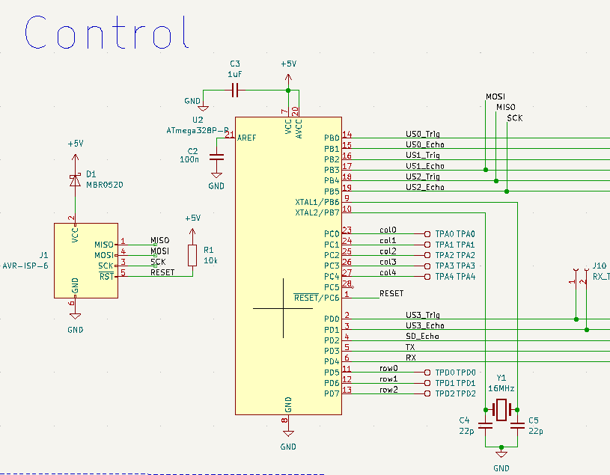

Figure 1. Crib Control Subsystem without Bluetooth Module Schematic

*Researching Bluetooth Module*

Since our project will include pairing two Bluetooth modules, it requires a Bluetooth module that can be set to the master mode. In this case, the HC-05 Bluetooth module is chosen.

There are two operating modes for the HC-05 Bluetooth module.

1. Data mode: In this mode, HC-05 sends and receives data based on Bluetooth protocols through the ports defined as Serial pins.
2. ATCommand mode: HC-05 stops transmitting data and is ready for configuration from ATCommands.

The following figure shows the interfacing of the HC-05 Bluetooth module. As the figure depicts, I only need four of these pins:

1. Vcc pin(connect to 5 V)
2. GND pin(connect to 0 V)
3. RX(connect to Arduino UNO TX pin)
4. TX(connect to Arduino UNO RX pin)

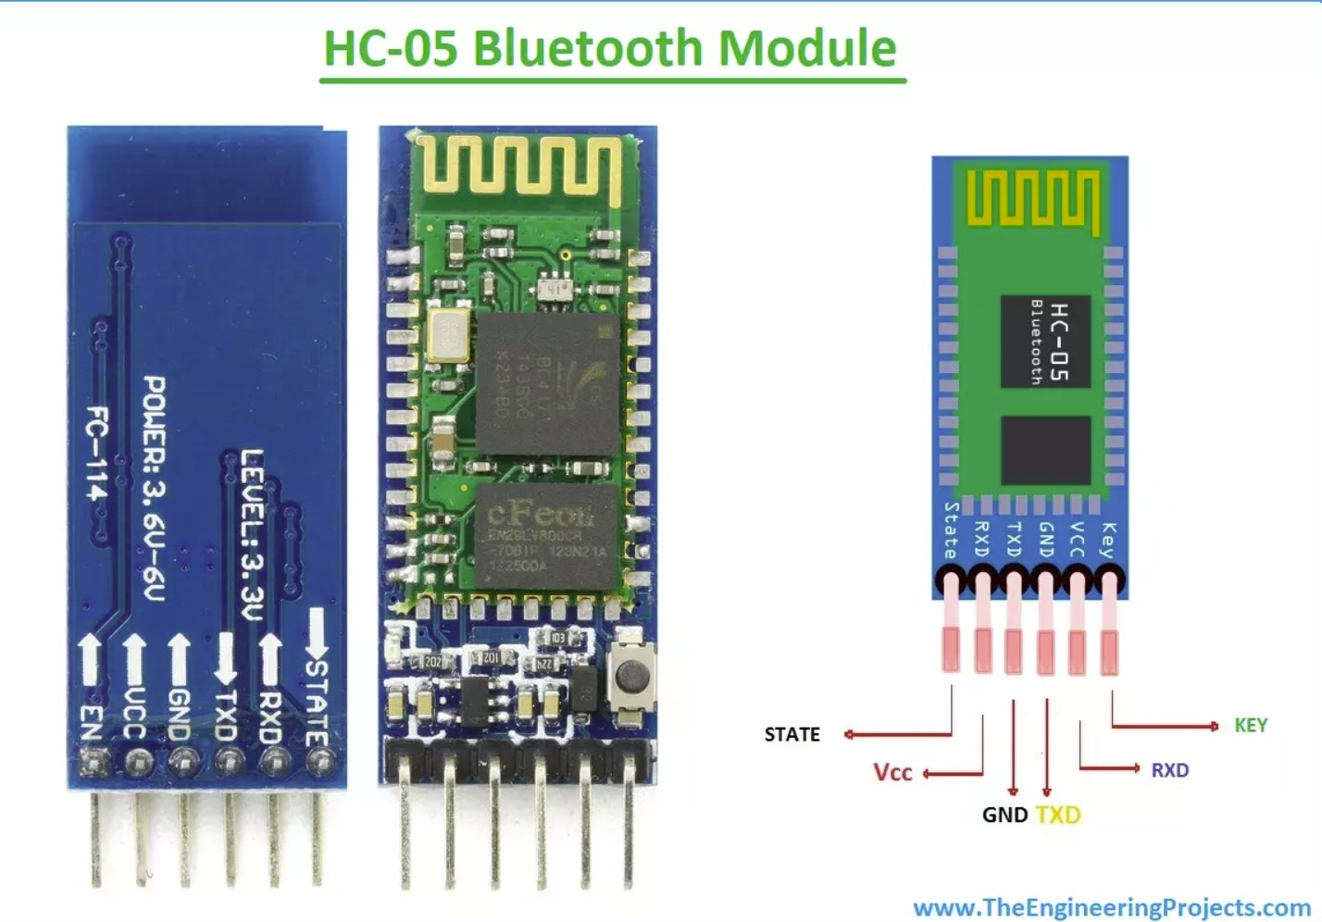

Figure 2. HC-05 Bluetooth Module Pin Assignments

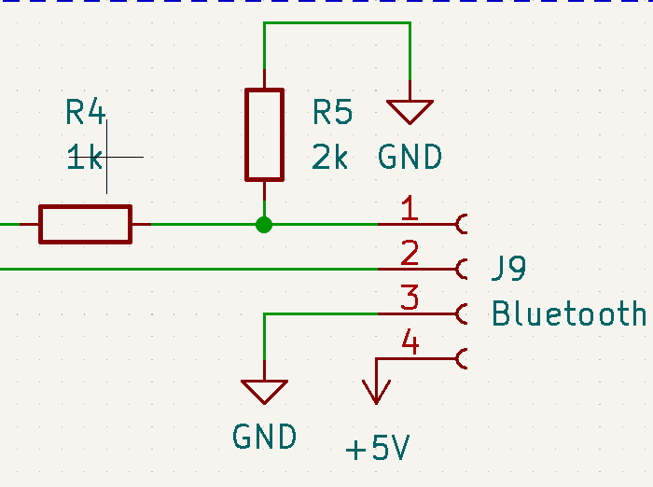It is also important to note that the RX pin of the HC-05 requires a maximum 3.3 V voltage instead of 5 V. To achieve this, I applied a voltage divider such that the voltage swing at the RX port is between 0 to 3.3 V.

Figure 3. Crib Control Subsystem Bluetooth Module Schematic

To physically pair two HC-05 Bluetooth modules, we need to set both devices into the ATCommand mode. What I did is first power off the HC-05, press and hold the button on the module, and re-connect the power. The device then enters the ATCommand mode and is ready for configuration. Then I set up the following commands on the slave and master devices, separately [3]:

Slave Device

1. “AT+ROLE=0” sets the device itself to become slave mode.
2. “AT+ADDR?” gets the address of the slave Bluetooth module. Master Device
3. “AT+ROLE=1” sets the device itself to become master mode.
4. “AT+CMODE = 1” sets the address of the slave Bluetooth module.
5. “AT+BIND = Address of the slave Bluetooth module”.

After these procedures, I re-connected these modules to power. The LEDs on the Bluetooth modules shine around once per two seconds, indicating that they have successfully paired.

Regarding the verification, I have already configured our Bluetooth modules through Arduino. Using the Arduino Uno development boards, we can successfully transmit and receive the data. But the data must be sent out in the format of an ASCII value, and the receiver end decodes that ASCII value and can print out its corresponding character.

## Power Subsystem

The subsystem is responsible for supplying electricity to the crib PCB board. The board includes a battery source that produces 9 volts and has a capacity of 1300 milliampere-hour, along with a linear voltage regulator. The regulator is used to convert the 9 volts into 5 volts, which is achieved by following a specific formula as stated in reference [4].

𝑉

𝑂𝑈𝑇

𝑅

= 1. 25 𝑉 × (1 + 2 )

𝑅

1

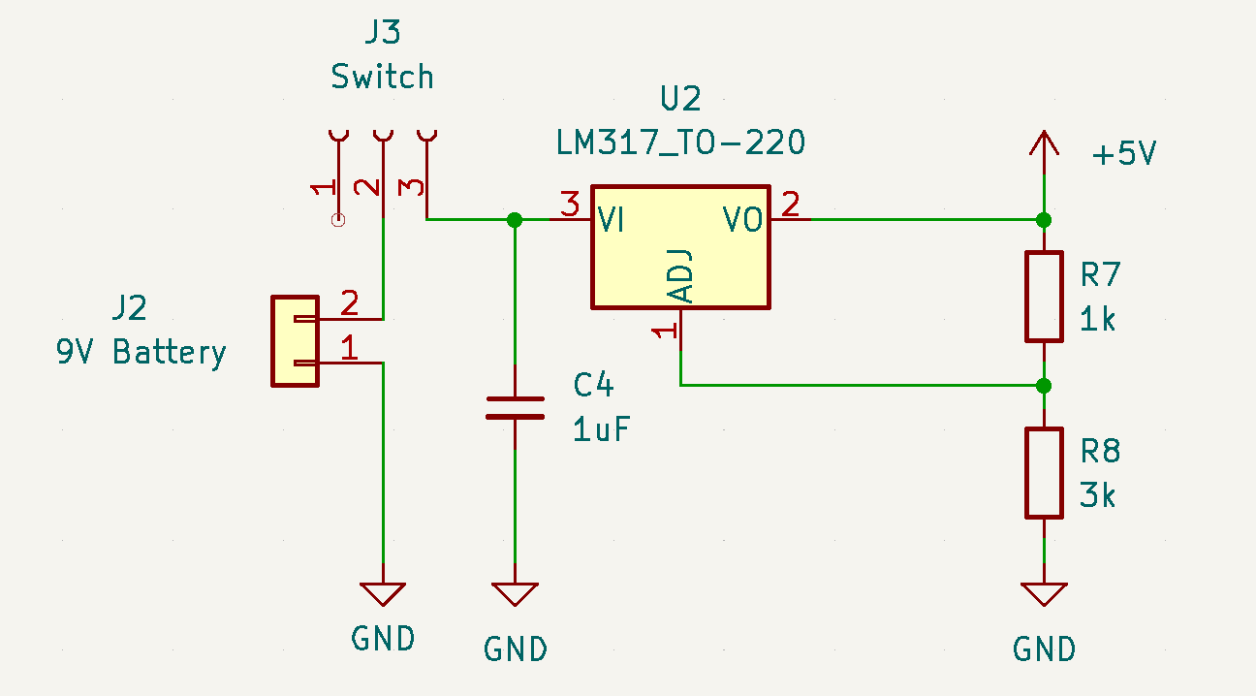To ensure that the sensors and MCU receive a 5 V power supply, we select values for R2 and R1 in a way that maintains a proportion of three, resulting in a 5 V output voltage. These components make up the majority of the power requirements for the system. A switch is inserted between the voltage regulator input and the battery such that it can be electronically turned on and off.

Figure 4. Crib Power Subsystem Circuit Schematic

We’ve brought the components to the ECEB 2070 to test the voltage regulator. It turns out that if we keep the R1 and R2 at the same ratio as 3, the output voltage supply will be 4.9V, which is approximately near the 5 V supply voltage.

## Crib PCB Design

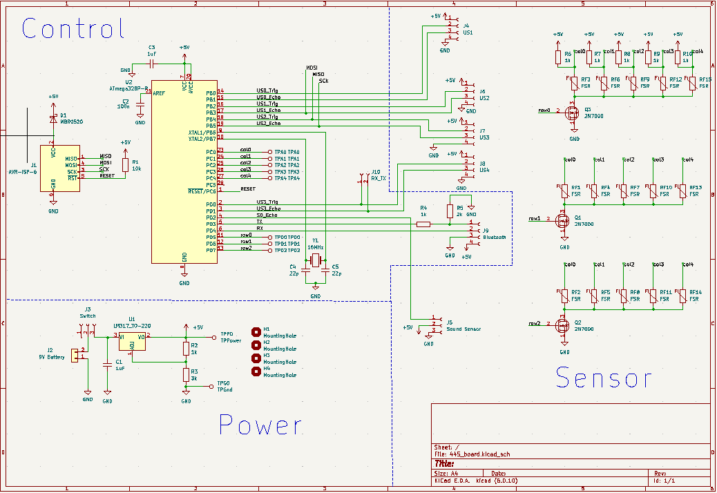I am in charge of designing the entire crib PCB. It contains a Bluetooth module, a sound detector, 15 pressure sensors, and four ultrasonic sensors. Since the PCB width limit is only 10 mm, I need to manage the area wisely. Also, preventing air wiring and keeping the distance between through-hole components and wires are significant since improper soldering will short the circuit. The following figures are my designed crib PCB schematic and layout.

Figure 5. Crib PCB Circuit Schematic

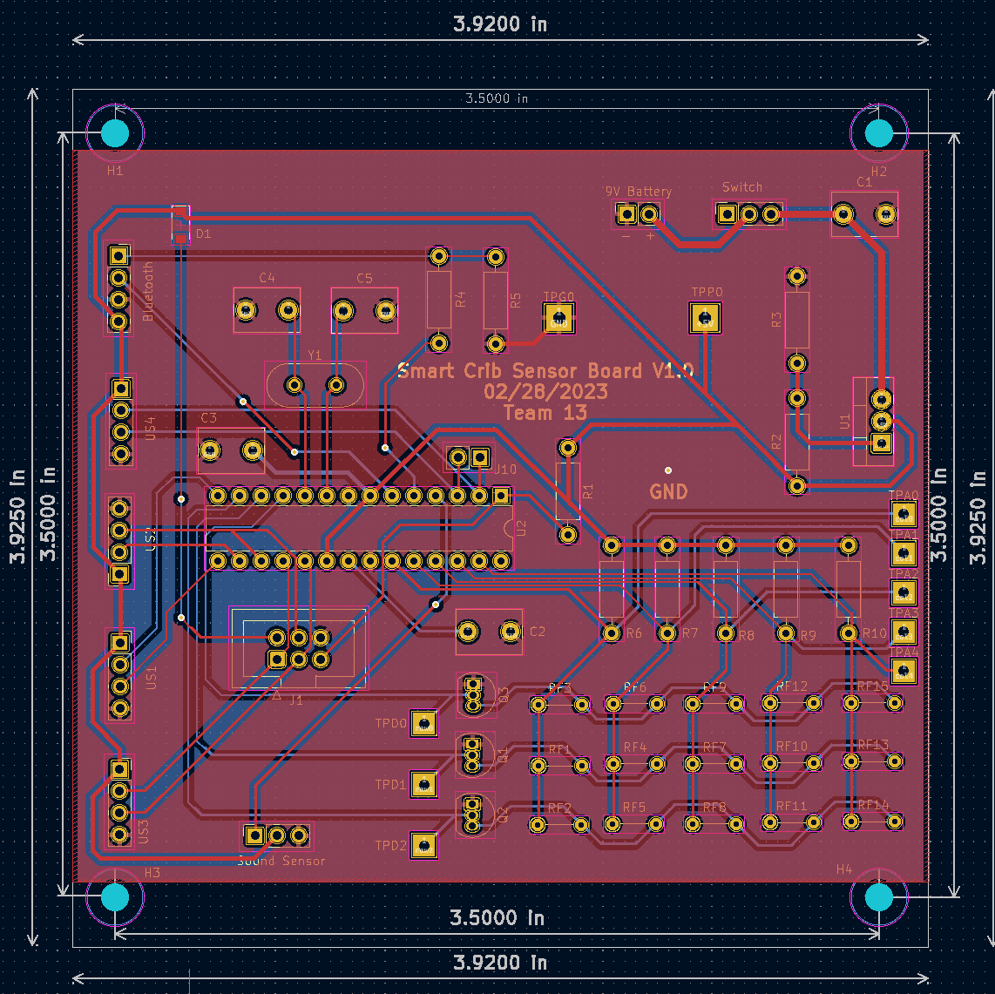

Figure 6. Crib PCB Circuit Layout

# Conclusion

Regarding future planning, I will still be in charge of fixing bugs in my designed PCBs if issues are encountered and re-submit them for fabrication if necessary. Since our team will integrate everything, I will also solder the parts I’ve designed. The following form is the timeline for completing my responsibilities and our project.

|  |  |
| --- | --- |
| 3/26-4/1 | Fix bugs and reorder the PCB if necessary and solder crib control and power subsystems on my designed PCB. |
| 4/2-4/8 | Verify the entire hardware in the designed PCB. |
| 4/9-4/15 | Continuing verifying the hardware if necessary. Integrate all the subsystems together, and prepare for the mock demo |
| 4/16-4/22 | Revise the project in detail if necessary and work on preparing the final demo |
| 4/23-4/29 | Work on the final report |

Table 1. Timeline for Project Completion

As an ethical reminder, I am consistently and will continue to help other team members on their responsibilities if issues arise and they cannot figure them out themselves.

# Reference

[1]“ATMEGA328P - Microchip Technology.” [Online]. Available: https://[www.microchip.com/en-us/product/ATMEGA328P.](http://www.microchip.com/en-us/product/ATMEGA328P) [Accessed: 28-Mar-2023].

[2]-Website Author Syed Zain Nasir syedzainnasir I am Syed Zain Nasir, shayantikadhar Says: and kodjo Says: “HC-05 Bluetooth module pinout, Datasheet, features & applications,” *The Engineering Projects*, 22-Jun-2021. [Online]. Available: https://[www.theengineeringprojects.com/2019/10/hc-05-bluetooth-module-pinout-data](http://www.theengineeringprojects.com/2019/10/hc-05-bluetooth-module-pinout-data) sheet-features-applications.html. [Accessed: 28-Mar-2023].

[3]-Website Author Syed Zain Nasir syedzainnasir I am Syed Zain Nasir, shayantikadhar Says: and kodjo Says: “HC-05 Bluetooth module pinout, Datasheet, features & applications,” *The Engineering Projects*, 22-Jun-2021. [Online]. Available: https://[www.theengineeringprojects.com/2019/10/hc-05-bluetooth-module-pinout-data](http://www.theengineeringprojects.com/2019/10/hc-05-bluetooth-module-pinout-data) sheet-features-applications.html. [Accessed: 28-Mar-2023].

[4] "LM317 3-Terminal Adjustable Regulator," [Online]. Available: https://[www.ti.com/lit/ds/symlink/lm317.pdf?ts=1666119013015&ref_url=https%253](http://www.ti.com/lit/ds/symlink/lm317.pdf?ts=1666119013015&ref_url=https%253) A%252F%252F[www.](http://www/) google.com%252F